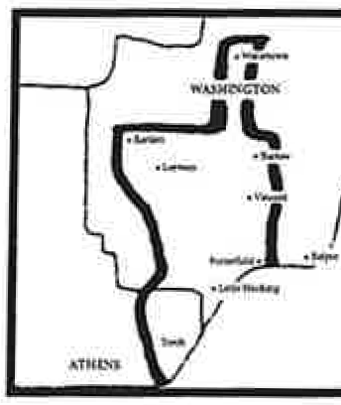
LITTLE HOCKING WATER ASSOCIATION, INC.

3998 Newbury Rd.· P.O. Box 188 ·Little Hocking, OH 45742 (740) 989-2181 Fax: (740) 989-5543
Website: www.littlehockingwater.org

LEAK PROTECTION PLAN

The Board approved the following Leak Protection Plan. As you know the billing is behind for approximately one month. The Leak Protection Plan would be in effect for any loss due to a leak occurring after December 31, 2025. Plan takes effect on the first meter reading after payment is received through the meter reading in December of each year.

1. The annual fee has been set at $25.00. A form will be mailed to each customer prior to January
1st. Payments will be accepted until April 30, 2026, for the 2026 plan year.

2. The customer would be required to notify the Association when a leak is discovered and when repairs are completed. This will ensure that the correct time frame is being used to calculate the loss. The customer will pay their average usage, which is held in the computer based on the last twelve months, and the balance of the bill would be paid from the Leak Protection Plan. We reserve the right to request proof of repair and the right to refuse due to negligence and/or lack of action by the customer.

3. Under the Leak Protection Plan, Little Hocking Water Association will pay up to $500.00, per year/per tap, toward the cost of the water leak over and above your average monthly usage. After the maximum of $500.00 is reached, the customer is responsible for all costs for the remainder of the year. The plan cannot be used to cover the cost of filling a pool, as this is not a leak.

4. DO NOT ADD YOUR LEAK PROTECTION PAYMENT TO YOUR WATER BILL. If you do, your $25.00 payment will be processed as payment of your bill to your account. ALSO, NO PAYMENTS WILL BE ACCEPTED AT THE LITTLE HOCKING WATER OFFICE.

If you are interested in participating in this program, please complete the form below making checks payable to LHWAand return with your payment of $25.00 to the Belpre Branch of The Citizens Bank. Payments MUST BE mailed to The CITIZENS BANK, PO BOX 38, Belpre, OH 45714.

LEAK PROTECTION PLAN FORM

Please deposit into LHWA Leak Protection Plan Account ending in *0298

Name:
Account#
Address:
Phone#
Signature:
Date:

